German Chocolate Cheesecake
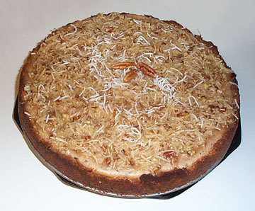 | Coconut Pecan Topping:  - 1/2 cup or 1 stick butter or margarine  - 1/4 cup light brown sugar  - 2 tablespoon light cream  - 2 tablespoon corn syrup  - 1 cup flaked coconut  - 1/2 cup chopped pecans  - 1 teaspoon. vanilla  Filling:  - 4 bars (4oz.)Hershey's semi-sweet baking chocolate, broken into pieces  - 3 pkgs. (8 oz. each) cream cheese softened  - 3/4 cup sugar  - 1/2 cup sour cream  - 2 teaspoons vanilla  - 2 tablespoons all purpose flour  - 3 eggs  Coconut-Pecan Crust:  - 2 cup graham cracker crumbs  - 4 tablespoon sugar  - 2/3 cup butter, melted  - 1/2 cup coconut  - 1/2 cup pecans, chopped
PREPARATION:
Topping:
Melt butter with sugar, stir in remaining topping ingredients and set aside.

Crust:
Combine crust ingredients; press into pan and bake at 350° for about ten minutes. I use a large spring form pan.

Filling:
Heat oven to 450°
- In microwave bowl, melt chocolate until smooth. Set aside and let cool until it is still liquid but not hot.
- In large mixing bowl, combine cream cheese, sugar, sour cream, and vanilla; beat with a mixer until smooth. Let sit till its room temperature.
- Add flour 1 tablespoon at time, blending well after each addition.
- Add eggs and melted chocolate; blend well.
- Pour into crust.
- Bake 10 minutes without opening oven door; reduce oven to 250° and continue baking 35 minutes.
- Remove from oven. With knife loosen sides and cool completely. Remove from pan.
- Spread topping on top and refrigerate until firm.
- Store uneaten portion covered, in refrigerator.

