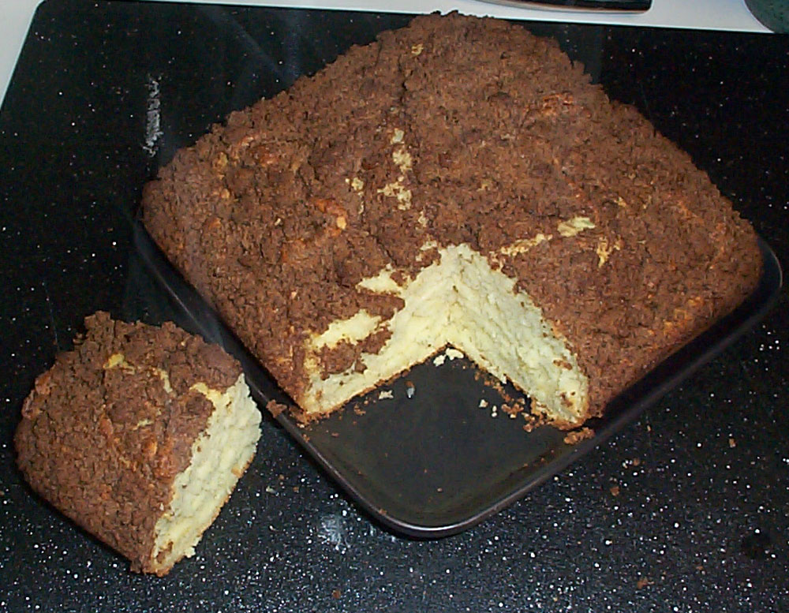 | Cake:  - 2 cups flour  - 3 teaspoons baking powder  - 1 teaspoon baking soda  - 1 teaspoon salt  - 2 tablespoons shortening  - 1 egg  - 1 1/3 cup milk  - 1 tablespoon sugar  Topping:  - 1/4 cup flour  - 2 tablespoons sugar  - 1/2 cup firmly packed brown sugar  - 1 teaspoon cinnamon  - 2 tablespoons butter, firm
Coffee Cake

Mix all the Cake ingredients together and place in a greased 9 inch pan.

In a separate bowl mix Topping ingredients together with a fork until crumbly. Sprinkle it all onto cake. Or put a little on the cake batter and swirl it in with a knife to give it a marbled affect. Then dump the rest of the topping on top of the cake batter. Cook at 400 degrees F for about 25 minutes.

