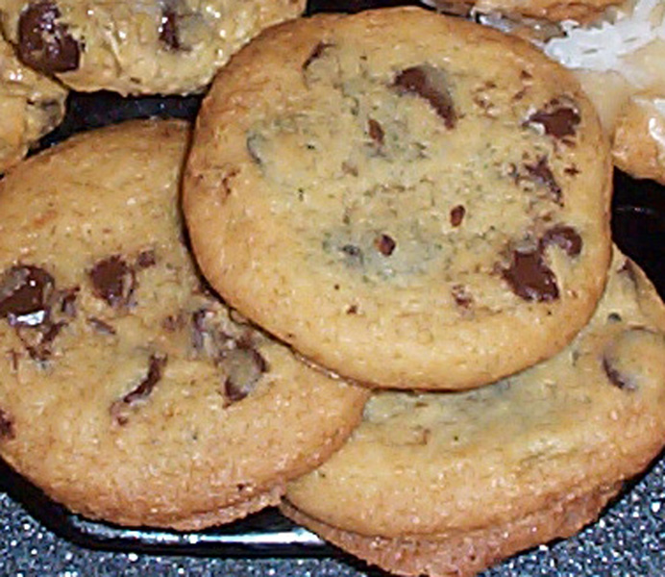 | Ingredients:  - 1 cup Butter Flavored Shortening  - ¾ cup Sugar  - 1 cup Brown Sugar  - 2 ¼ cups Flour  - 1 tsp salt  - 1 ½ tsp baking powder  - 2 eggs  - 1 ½ tsp vanilla  - 2 cups chocolate chips
Chocolate Chip Cookies

Preparation Directions:
1. Heat oven to 375F. In large bowl, combine brown sugar, sugar, and shortening; beat until light and fluffy. Add vanilla and egg; blend well. Stir in baking powder and salt.
2. Gradually mix in flour.
3. Stir in Chocolate Chips
4. Chill in freezer for at least 1 hour or until dough is nice and firm. I put my dough on a sheet of waxed paper and roll it up. That way I can leave it in the freeze as long as I need (but it never lasts there long).
5. Place on a cookie sheet in balls and bake at 375°F until desired color. I like mine a little soft in the middle but others might like them crunchy so just do what works for you here. But once the sides are turning brown take them out or they will burn.
6. Remove from pan as quickly as possible and place on a cooling rack. Cooking parchment makes this a lot easier.

